Build log spider Introduction

1. Start point of Build log spider script
   1. Check the build errros on Dapeng for Project Generate tool test cycle through automation.

Show as the picture, it has about more than 4600 failed case, It’s a buge workload to check every failed cases and errors.

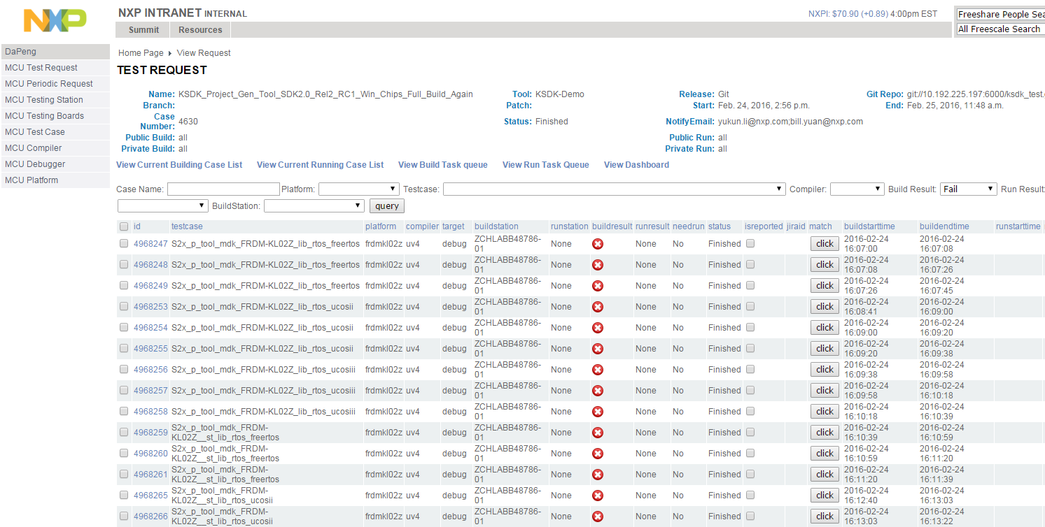

* 1. It’s easier to classify failed cases and errors for reporting bugs through automation.

It is part of result log showed as the following picture. It’s clear to know what build error happened in what case of which board.

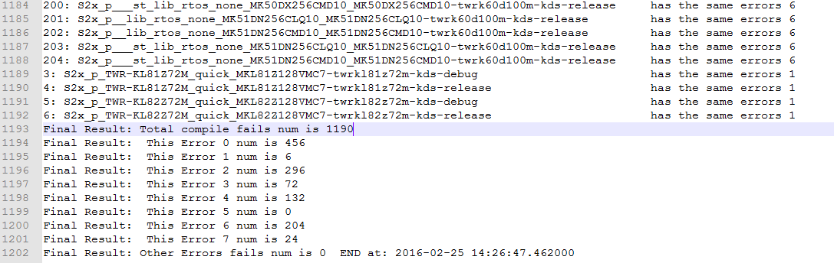

1. Overview for the build log spider script

The script is based on the analysis of the source page of the web.

The main URL address is:

URL=[**http://10.192.225.198/dapeng/EditMcuautoRequest/3367/?showall=1&compilerid=3&buildresult=2**](http://10.192.225.198/dapeng/EditMcuautoRequest/3367/?showall=1&compilerid=3&buildresult=2)

In this URL, the” 3367” means the dapeng request number. The “compilerid = 3” means the current compiler is “iar”, and the “buildresult = 2” means the page is about build fail case.

This is the workflow of the script.

1. Direction for use

User has to configure the basic settings before running the script.

(1)“NO” is the Dapeng request number which need to be check.

(2)“compiler_name” is the short name for compiler which user want to test. The script just run only one compiler platform every time because you can see the results immediately.

(3)“compare_dict” is about all kinds of error types about every compiler. It need user to check out the new error and add to the dict. If one error type is not in the dict and cases has this error type. The script will remind user which cases has the others errors in the log.

# ============configure the compare info===================

NO = '3367'

compiler_name = "atl"

compare_dict = {

'iar': [

"

"Fatal Error.* cannot open source file .*fsl_uart.h",\

“………………..”

],

'uv4': [

"error:.* identifier .*ENET_EIR_BABR_MASK.* is undefined",\

“………………..”

],

'atl': [

"fatal error: portmacro.h: No such file or directory",\

“………………..”

],

'kds': [

"duplicate definitions for .*s_dummyData",\ ]

“………………..”

}

# ========== end configure===================================

1. Advantages and problem
2. Improve the work efficiency

In1 hour = check the “iar” compiler build log about 860 failed cases + findout the 7 build errors + report 5 bugs on 5 board flatforms;

In 30 mins = check the “kds” compiler build log about 1900 failed cases + findout 3 board platforms has one same old error and 5 same errors with iar compiler .

1. Problems
   1. Need people to check and add new errors.
   2. Note that maybe two or three errors in the same case.
   3. Should be more faster.
2. **Scripts and attachments**